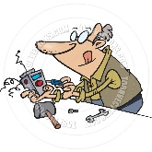  Inventor Club  Here you will use your imagination and curiosity! We will create new things each week from everyday items! You may build a plane, car, guitar & more! | 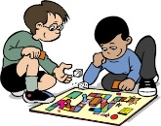  Board Game Club  In game club we will play board games, cards, bingo and minute to win it games. We’ll make our own board games too!
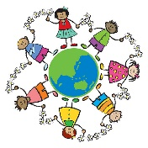  Around the World Club  In this club, we will talk about different places around the world! We will explore together. |   YogaFit Club  In YogaFit we will practice yoga, stretching, playing soccer, dance, and volleyball. We will be practice being active!
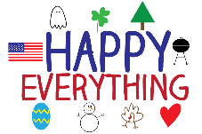  Holiday Club  We will talk about Holidays or seasons at that time. Scholars will watch videos, read books, sing songs and make crafts. | 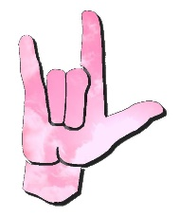  Sign Language Club  In this club, you will learn how to talk in a new language.
  Cheerleading Club  In cheer club, you’ll learn the basics of being a cheerleader. From learning arm motions, to techniques, to stunting. | 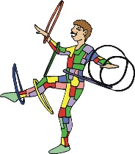  Circus Club  Have you ever dreamed of hooping, juggling, tight rope walking, spinning, balancing an rolling on the circus stage? If so, Circus Club has your ticket!
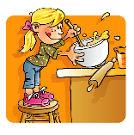  Cooking Club  We will let our taste buds be the judge as we develop our measurement skills in preparing food! We’ll make breakfast, grilled cheese, & more! | 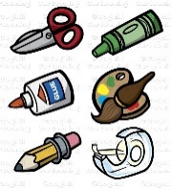  Crafting Club  In crafting club we’ll create fun and different crafts. You will leave every day with a craft to take home and show off to your friends and family.
  Penpal Club  In this club, we will write letters to famous people, the President, and people that live around the world! | 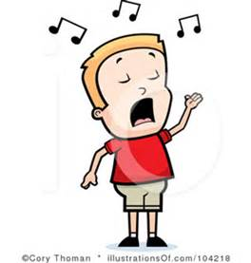  Singing Performance Club  In this club, you will work on your performing and singing club.

